TypeScript

cheat sheet

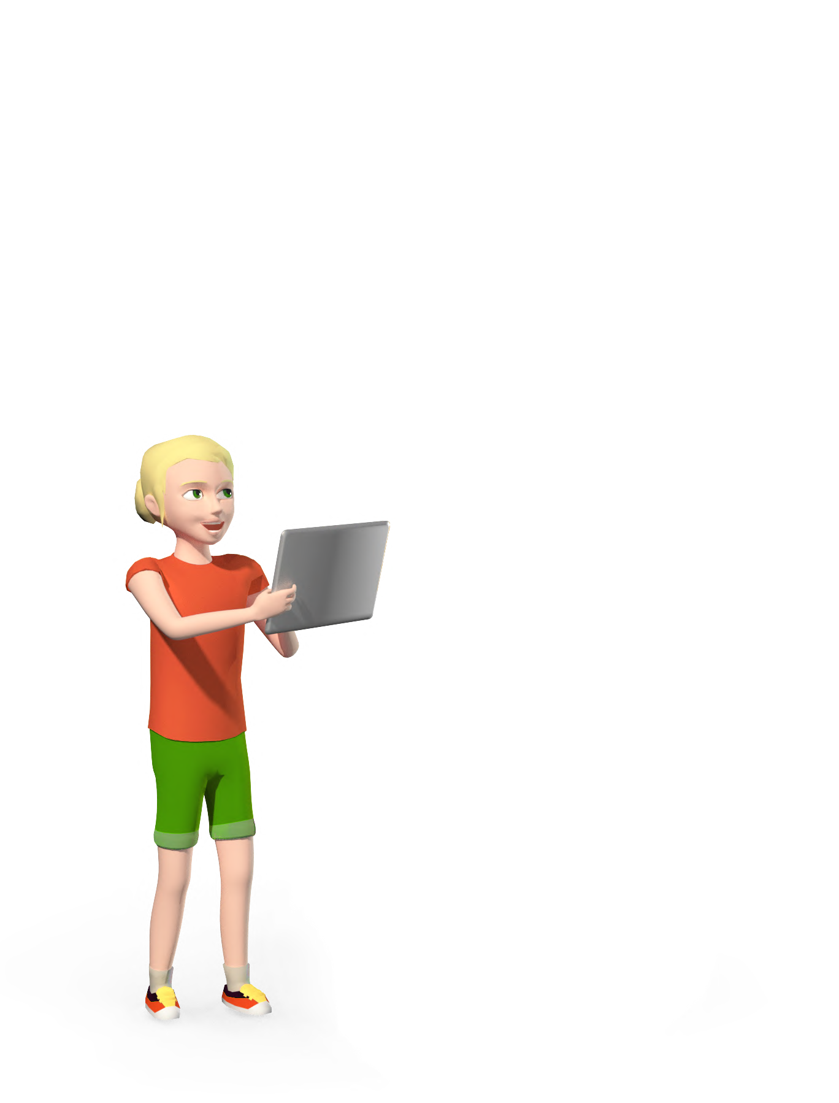

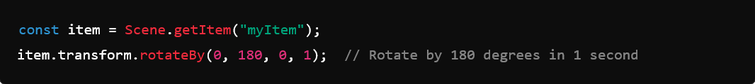

my item

is clicked

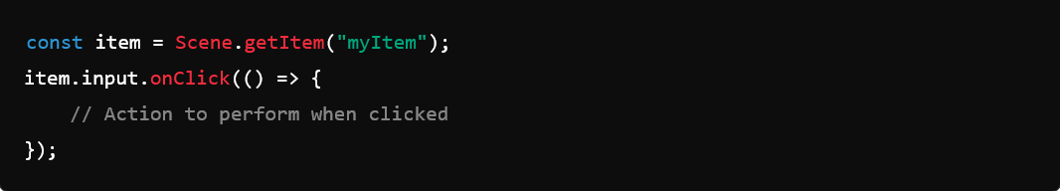



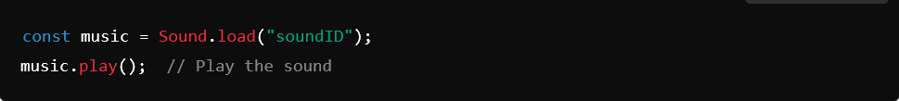

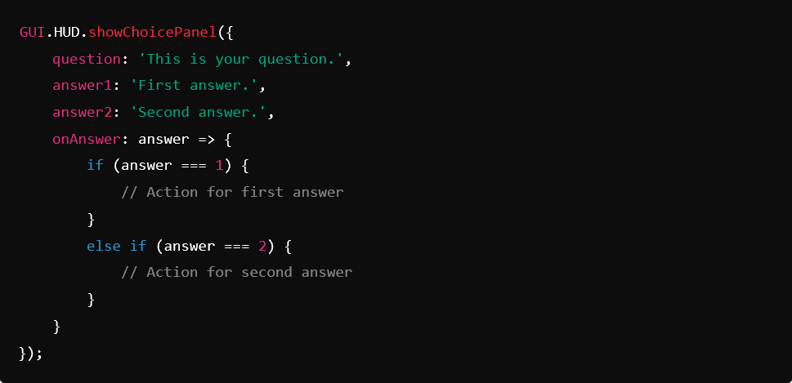

Last update: September 2024

**Quick descriptions of**

**the beginners TypeScript manual**

**Transform**

**Action to perform TypeScript code to use**

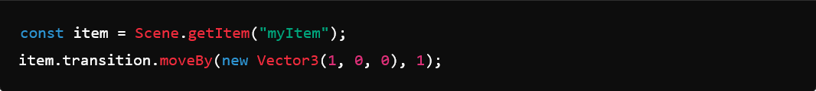

Move item by 1 meter on the x-axis in 1 second.

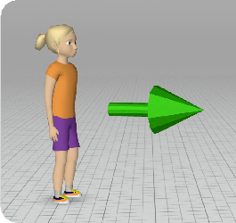

**Move** an Object or Character over time

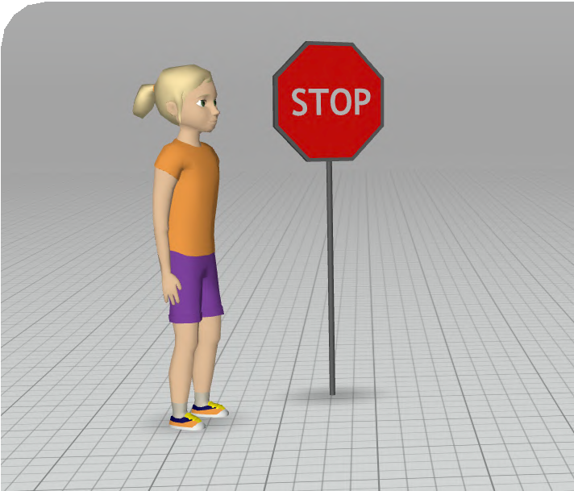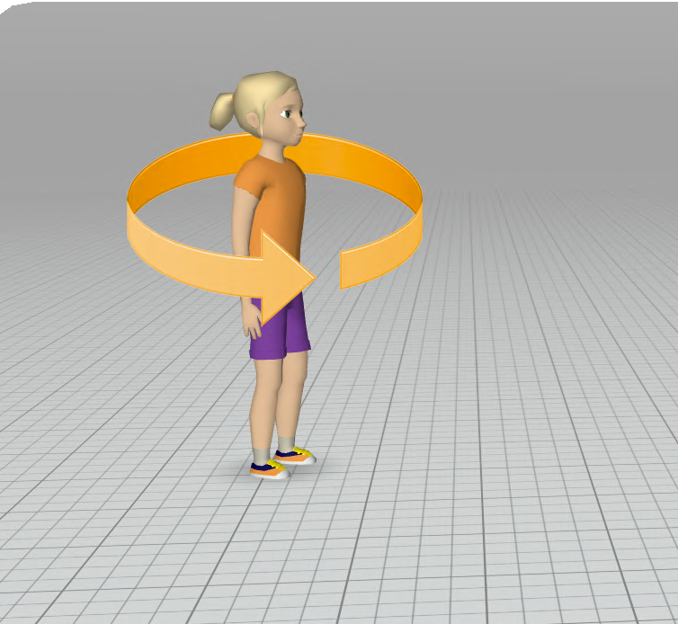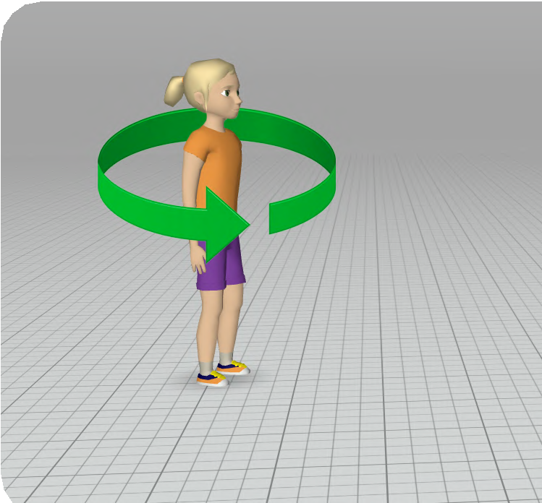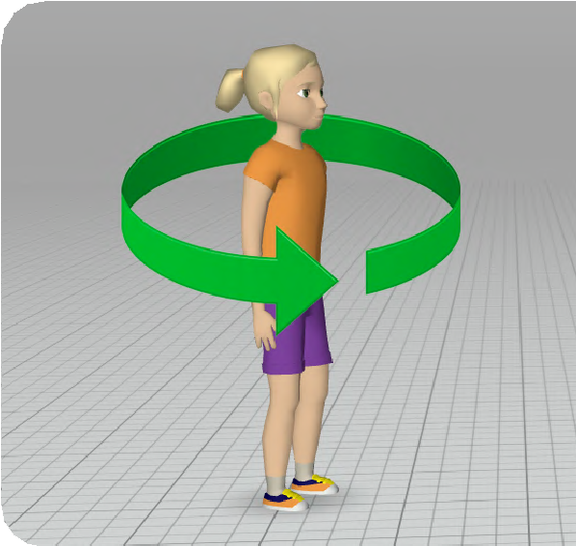

**Local Rotation** of Object over time

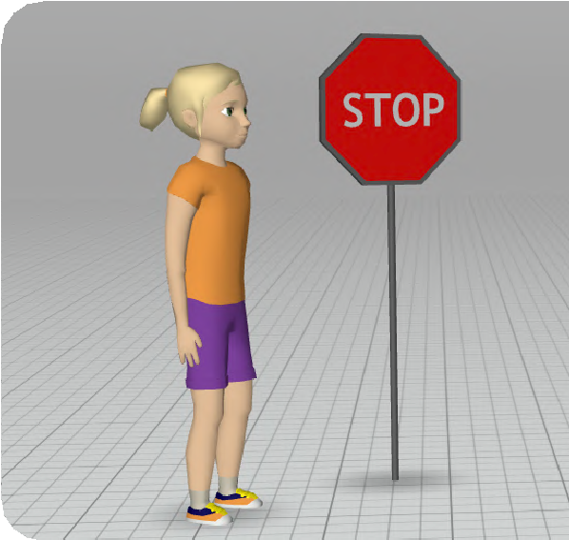

**Stop** an object or a character

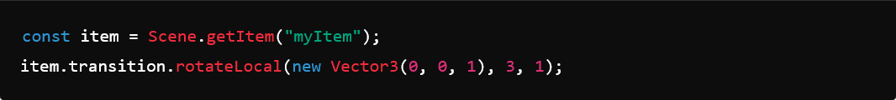

Rotate item locally by 3 degrees on the z-axis in 1 second.



**Events**



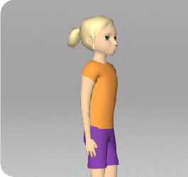

Make something happen

**when** an item **is clicked**

**Control**

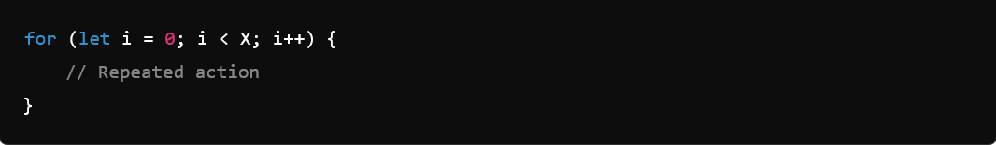

Repeats the action **X** times

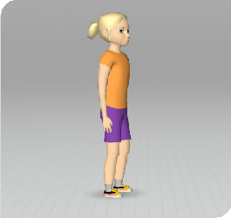

**1**

Make one or more actions

**repeat** a certain amount of times

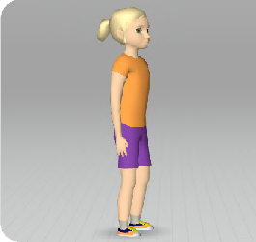

Make my program **wait**

for some time



**Go to** specific **scene**.

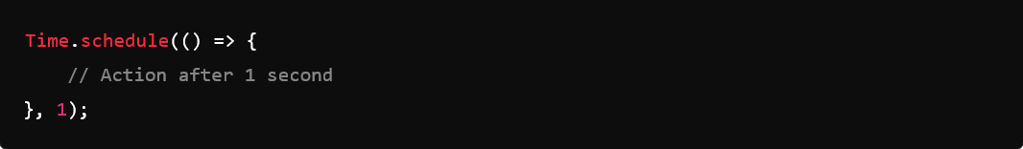

Performs the action after 1 second.



Switches to scene with ID **1**.

**Actions**

**Action to perform TypeScript to use**

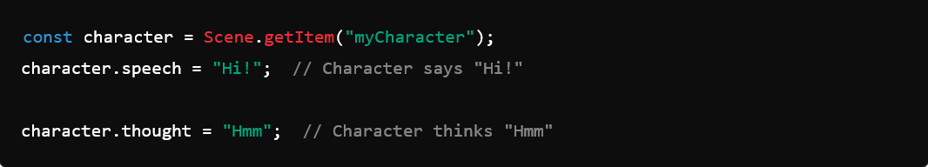

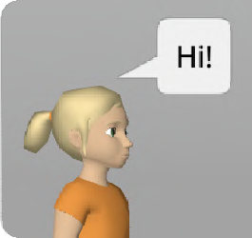

Make a character **say** or

**think** something

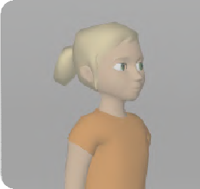

Change the **opacity** of an item

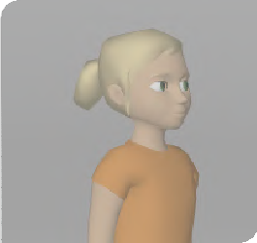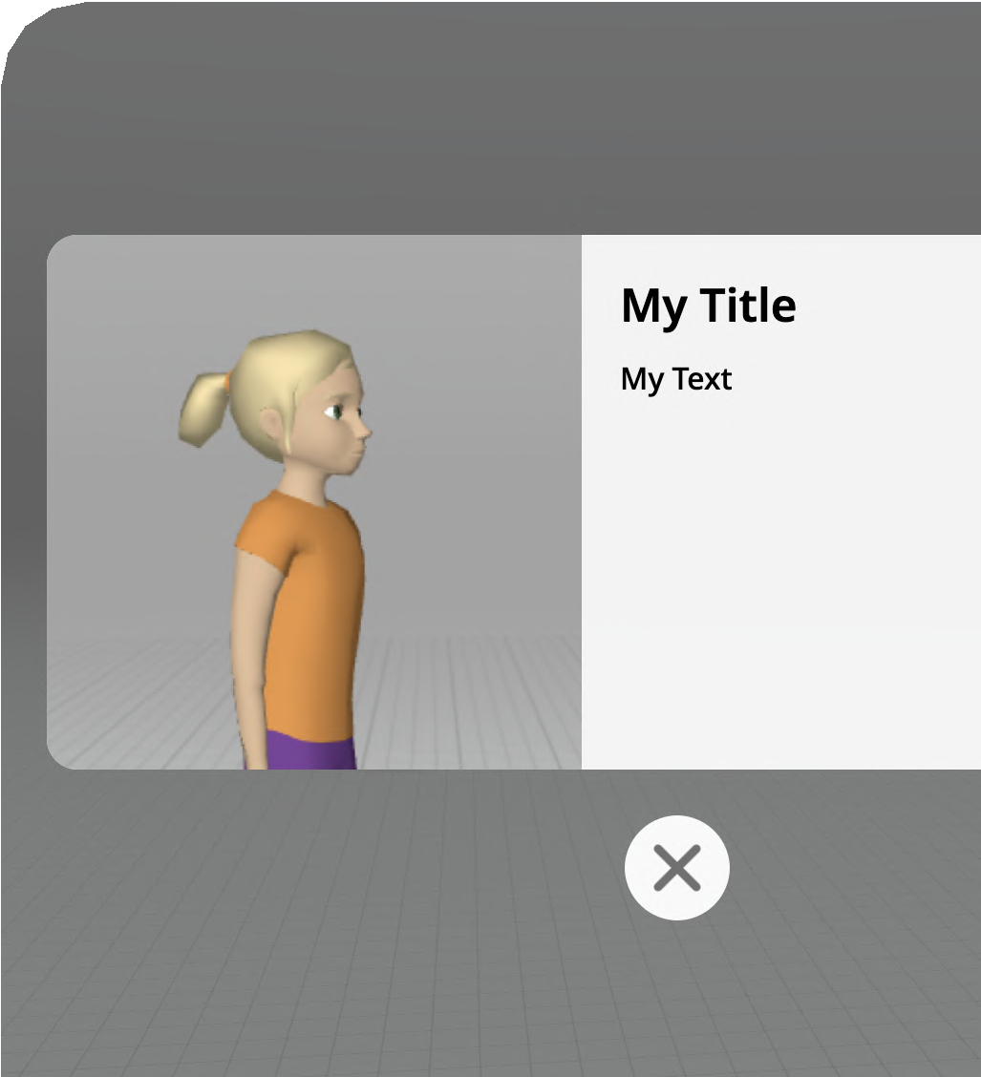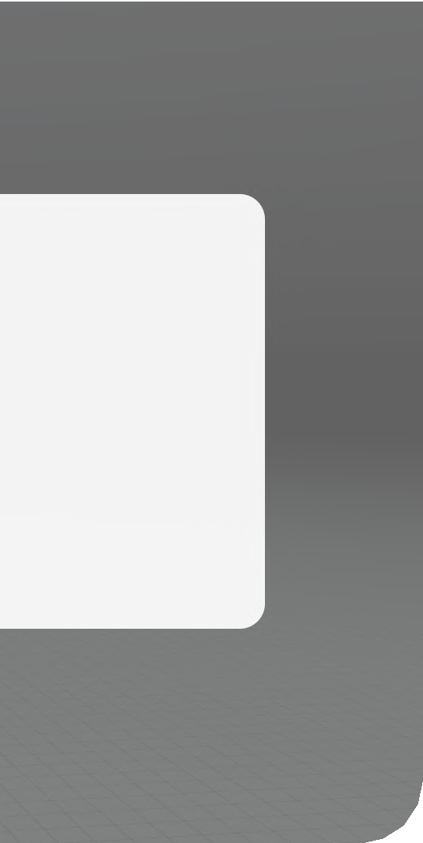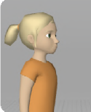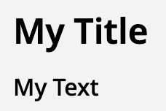

Show an **info panel** with a title, text (and an image)

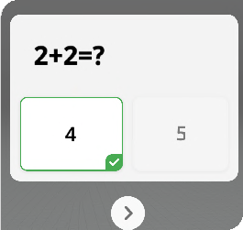

Show a **quiz panel** with a question and answers that can be clicked and

will trigger an action when the selected answer is correct or incorrect.

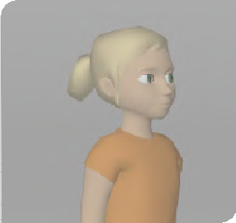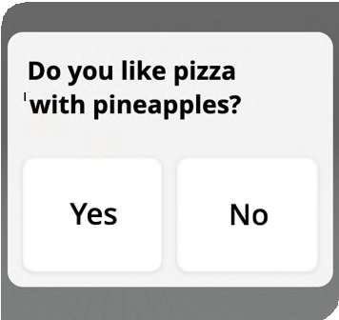

Show a **choice panel** with a question and options that can be clicked and that trigger different actions.



Play a **sound** file



**Stop** playing the **sound**

file

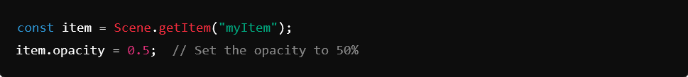

Sets the opacity**(see-through level)** of the object to 50%.

